The Order of Holy Eucharist for Palm Sunday
All gather in the courtyard with palms in hand.
A bell is sounded three times to call our attention to God.

Blessed is the King who comes in the name of the Lord.
Peace in heaven and glory in the highest.
Let us pray.
Assist us mercifully with your help, O Lord God of our salvation, that we may enter with joy upon the contemplation of those mighty acts, whereby you have give us life and immortality; through Jesus Christ our Lord. Amen.

Reading of the Gospel (Found in the reading handout)

Blessing of the Palms
The Lord be with you.
And also with you.
Let us give thanks to the Lord our God.
It is right to give our thanks and praise.
It is right to praise you, Almighty God, for the acts of love by which you have redeemed us… Amen.
The palms are sprinkled with Holy Water as a sign of blessing.

Let us go forth in peace.
In the name of Christ. Amen.
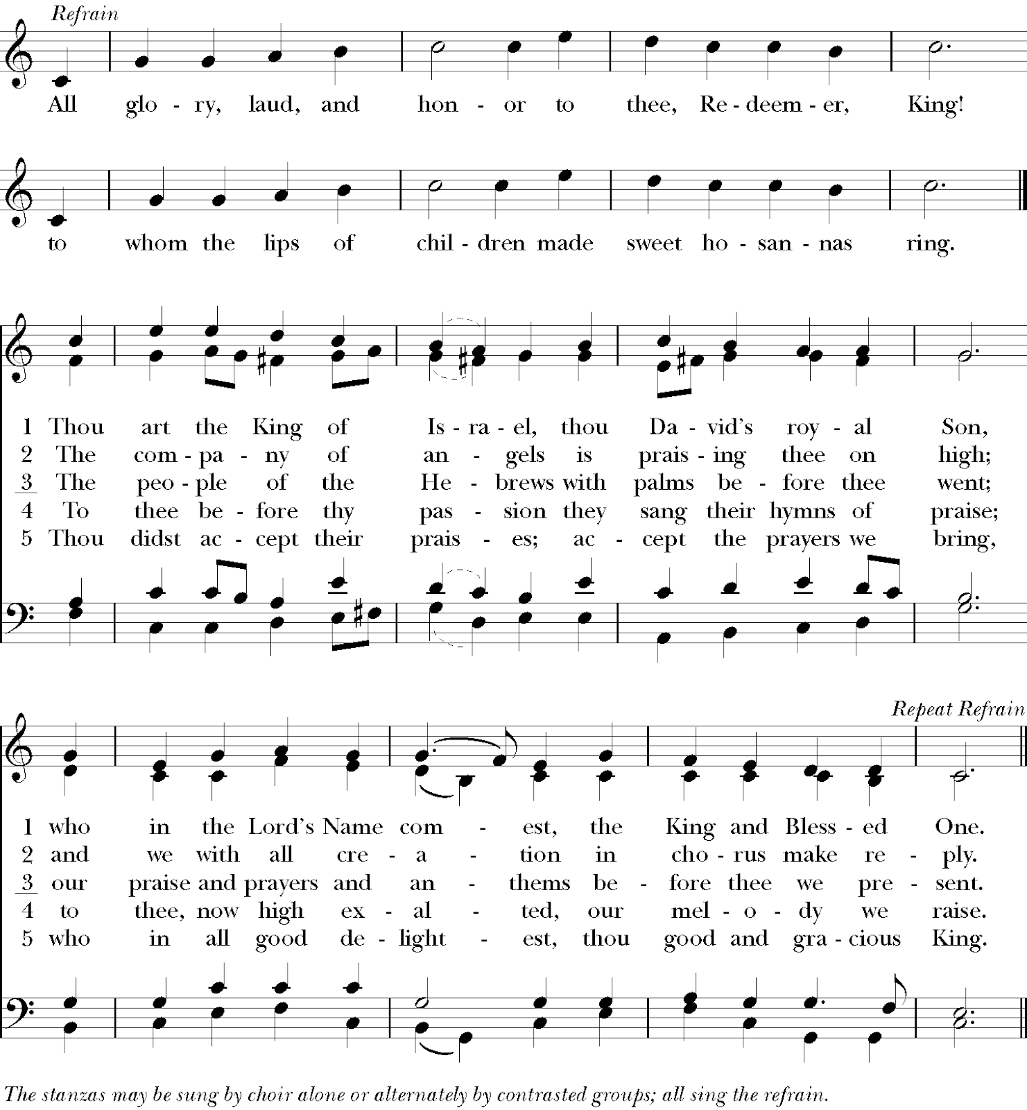

The Lord be with you.
And also with you.
Let us pray/ Oremos …
… now and for ever. Amen.

Scripture & Homily

The Scripture readings can be found in the handout you received when you arrived.

Prayers of the People

The people pray, responding to each petition as indicated.

The Peace
The peace of the Lord be always with you.
And also with you.
The People greet one another in the name of the Lord.

OFFERTORY HYMN
The people bring forward their offerings and the Bread and Wine.
(To give online visit www.stfepiscopal.org)

The Great Thanksgiving
The Lord be with you.
And also with you.
Lift up your hearts.
We lift them to the Lord.
Let us give thanks to the Lord our God.
It is right to give our thanks and praise.

The Priest continues with the Prayer, then all sing:
THE SANCTUS
Holy, Holy, Holy Lord, God of power and might,
heaven and earth are full of your glory.
Hosanna in the highest.
Blessed is he who comes in the name of the Lord.
Hosanna in the highest.

The Priest continues with the Prayer, and then all respond to:
Therefore we proclaim the mystery of faith:
Christ has died. Christ is risen. Christ will come again.

The Priest says the final part of the Prayer, and all say:
AMEN.

The Lord’s Prayer (Spanish & English below)
And now, as our Savior Christ has taught us, we are bold to say,
Our Father, who art in heaven, Padre nuestro
que estás en el cielo,
hallowed be thy Name, santificado sea tu Nombre
thy kingdom come, venga tu reino,
thy will be done, hágase tu voluntad,
on earth as it is in heaven. en la tierra como en el cielo.
Give us this day Danos hoy
our daily bread. nuestro pan de cada día.
And forgive us our trespasses, Perdona nuestras ofensas,
as we forgive como también nosotros
perdonamos
those who trespass against us. a los que nos ofenden.
And lead us not into temptation, No nos dejes caer en
tentación
but deliver us from evil. y líbranos del mal.
For thine is the kingdom, Porque tuyo es el reino,
and the power, and the glory, el poder, y la gloria,
for ever and ever. Amen. ahora y por siempre. Amen.

The Priest breaks the consecrated Bread – silence - then:
Christ our Passover is sacrificed for us;
Therefore let us keep the feast.

FRACTION HYMN
How deep the Father’s Love for Us
Verse 1
How deep the Father's love for us
How vast beyond all measure
That He should give His only Son
To make a wretch His treasure
How great the pain of searing loss
The Father turns His face away
As wounds which mar the Chosen One
Bring many sons to glory

Verse 2
Behold the Man upon a cross
My sin upon His shoulders
Ashamed I hear my mocking voice
Call out among the scoffers
It was my sin that held Him there
Until it was accomplished
His dying breath has brought me life
I know that it is finished

Verse 3
I will not boast in anything
No gifts no pow’r no wisdom
But I will boast in Jesus Christ
His death and resurrection
Why should I gain from His reward
I cannot give an answer
But this I know with all my heart
His wounds have paid my ransom

CCLI Song # 1558110
Stuart Townend
© 1995 Thankyou Music
For use solely with the SongSelect® Terms of Use. All rights reserved. www.ccli.com
CCLI License # 22075753

Holy Communion
All who are Baptized are invited to receive Jesus Christ in both Bread and Wine. (Gluten free Bread is available.) Those who are not baptized may come forward for a Blessing.

COMMUNION HYMN

Prayer after Communion:
Eternal God, heavenly Father,
you have graciously accepted us as living members
of your Son our Savior Jesus Christ,
and you have fed us with spiritual food
in the Sacrament of his Body and Blood.
Send us now into the world in peace,
and grant us strength and courage
to love and serve you with gladness and singleness of heart;
through Christ our Lord. Amen.

Announcements & Blessings

CONCLUDING HYMN

Go in peace to love and serve the Lord. OR Let us go forth…
Thanks be to God. / Demos gracias a Dios.

Contact us
(505) 896-1999
stfechurch@gmail.com
Office/Chapel Hours: M-F 11am-2pm

Copyright and Licensing Information
Reprinted/ Podcast/ Streamed with permission under One License #A-720084. All rights reserved. CCLI License # 22075753

Learn more, Give online
www.stfepiscopal.org

